Cones of depression and catchment water fluxes in the vicinity of Catfield fen – the impact of groundwater abstraction (the stockade theory) – method of assessment.

by
Professor David Gilvear
22nd August 2012

Introduction
This documents outline the precise method of calculation on how the volumes of water abstracted from the groundwater catchment of Catfield fen may impact on fen water levels as quoted in the Catfield Fen investigation (AMEC, 2012; Page 80). It has been produced at the wish of Natural England following an earlier document explaining the “stockade” theory and presenting values of water level loss. The water levels given were expressed as water depth equivalents per day (mm). The actual water level change within the fen deposits will depend upon their porosity (e.g. peat is 90% water), the percentage of the water abstracted that would naturally makes its way to the fen and the natural time of travel of groundwater from the abstraction point to the fen. The water depth equivalent value should be seen as a possible maximum effect although it should be noted that if fen deposits had a porosity of for say 50% a 10mm water equivalent loss would result in a fen water level drawdown of 20mm.

Methodology outline
- The groundwater catchment area was estimated with reference to Figure B2 in the AMEC report (2012). This is the best known source of information on the groundwater contours and is likely to provide a good approximation of its extent. The boundary of the catchment was determined as the marked catchment divide to the east of Catfield and then to the north and south drawn at right angles to the groundwater contours (groundwater will flow perpendicular to the groundwater contours as a result of the hydraulic head difference) meeting up with the margins of the internal system at Catfield fen. The catchment area was approximated as 2.0km² (see Figure 1 attached). This is a very small catchment.
- The area of Catfield fen was estimated from a 1:10,000 map of the fen. The value used for this analysis was 0.5 km² (See Figure 1). It is worth noting that the fen to catchment area ratio is 0.25. This is a very high ratio of wetland area to catchment area. As such any groundwater lost to abstraction that would have flowed to the fen is likely to have a large effect.
- The location and extent of the spray irrigation groundwater cones of depression were based on them being centred on the abstraction point, them being circular in form and with a radius of 750 metres. These theoretical cones of depression occupy an area of 1.77 km² (based on πr²). Theis modelling predicts a drawdown of 1cm at 600 metres from the borehole and no drawdown at 1000 metres for the Plumsgate Road spray irrigation borehole (AMEC 2012; Page 54). It is realised that the full extent and shape of the cone of depression is difficult to quantify but in the presence of no conflicting information these assumptions seem valid. Given these assumptions it is estimated that 10% (0.180 km²⁾, 25% (0.44 km²) and 45% (0.80 km²)of the cone of depressions for Overton, Plumsgate Rd, and Ludham Rd (Alston) lie within the groundwater catchment draining to Catfield fen (see Figure 10. In total these areal extents equates to almost 71% of the estimated groundwater catchment. The equivalent value of the extent of AWS Ludham Road cone of abstraction within the catchment is estimated as 33%. Here the radius of the cone of depression was estimated as 1.2km. Where the cones of depression are seen to overlap drawdown of groundwater levels would extend further – this is important in that simple modelling of the cones of depression of individual abstractions will not match on the ground reality in the case of multiple abstractions in close proximity.
- To estimate the volume of water lost as water equivalent depth over Catfield Fen the licensed daily rate was used for each abstraction. This volume was then divided by the area of the internal system at Catfield fen and expressed as water depths equivalent per day .The values are 0.2 mm for Overton (based on licensed daily rate of 1.2MLD), 0.5mm for Plumsgate Road (based on a licensed daily rate of 1.090 MLD), and 0.7 mm Ludham Road (Alston) (based ona licensed daily rate of 0.8 MLD) (see worked example in Appendix 1). Thus the abstraction is withdrawing a combined total of 1.4 mm per day of water in terms of fen water depth equivalent. If we assume a dry weather period of 30 days this represents 42 mm or 4.2 centimetres as a maximum possible water loss (The abstraction licence for Plumsgate Road would permit 62 days of spray irrigation in a year at this rate). These values assume all the water abstracted would have made its way to the fen. However, the actual drawdown in fen groundwater levels will be more if we take in to account the fen porosity. Porosity values area not known but if they were say 50% the actual value of fen groundwater level drawdown would double to 8.4 centimetres. In comparison to the spray irrigation, the AWS Ludham Road abstraction (based on a licensed daily rate of 2.27 MLD) with an assumption of 33% of cone of depression within the Catfield fen groundwater catchment area has a similar value - 1.5 mm per day or over 30 days 45 mm or 4.5 centimetres. If once again we take a porosity value of 50% then the predicted actual maximum water level drawdown would be 9 centimetres. The effect of AWS Ludham and the spray irrigation would be 17.4 centimetres.

Conclusions
- Catfield fen has a small groundwater catchment feeding it and thus it is potentially highly sensitive to groundwater abstraction within the area.
- The methodology presented is sound in terms of predicting a maximum possible loss of water to Catfield Fen from groundwater abstraction in terms of water equivalent depth.
- The methodology predicts a maximum loss of water in terms of water depth equivalent over the fen of 4.2 centimetres over 30 days of maximum licensed spray irrigation and 4.5 centimetres from AWS Ludham once again based on maximum abstraction rates over 30 days. These values combined give a value of 8.7 centimetres water loss. If the porosity of the fen deposits is taken in to account the predicted maximum actual drawdown in fen groundwater levels will be larger or if pumping continued beyond 30 days.

REFERENCES
AMEC (2012) Catfield Fen Investigation, Final Report. Report to Environment Agency (Anglian Region)

Figure 1. A schematic representation of how theoretical circular groundwater cones of depression of radius 750 metres for spray irrigation boreholes and 1200 metres for the AWS Ludham Road borehole potentially impact on the estimated groundwater catchment of Catfield fen.

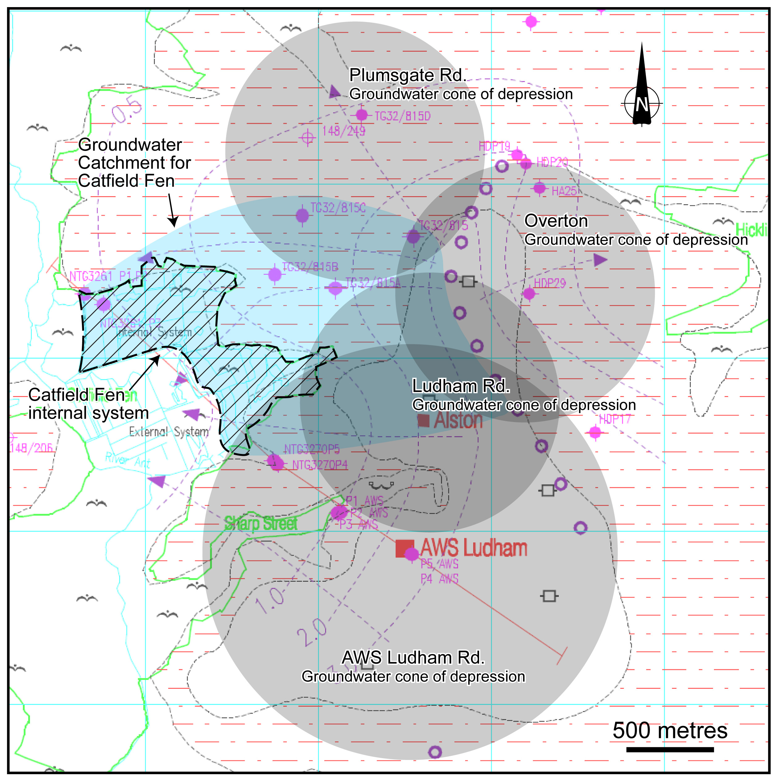

Appendix 1 - Method of calculation of maximum possible water level drawdown per day in water depth equivalents on Catfield fen due to the Plumsgate Road spray irrigation

Licenced maximum daily abstraction rate - 1.090 MLD
Catfield fen area (0.5km²)
1.090 million litres = 1090m³
0.5km² = 500000 metres
1090 divided by 500000 = 0.00218 metres (i.e.volume divided by area)
0.00218metres = 2.18 millimetres per day (depth of water over Catfield)
Given 25% of cone of depression is in catchment area of Catfield fen
2.18/4 = 0.545 millimetres per day

